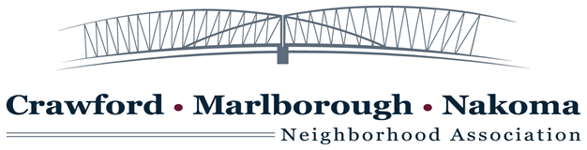

Agenda for April 3, 2017

Public Comment

Approval of Minutes

Reports

President — Mary Odell Make Madison Music Aldermanic Forum

Treasurer — Kim Kindschi

Planting Project/Gardening Plan — Carol Beulow

Old Business —

Good Neighbor Night April 26 — Ralph Stamler

New Business

Liaison efforts with the Nakoma League Board—Kevin Pomeroy

Ideas for Make Music Madison Night

Committee to help that evening

Any Fund Raising Possibilities How to Promote Participation in CMMNA.org

Other Topics for Future Meetings

Attendance: Area 1 – Mike Finnegan  – Area 1 – Vacant  
Area 2 – Mary Odell  – President –  Area 2 – Vacant  
Area 3 – Kim Kindschi  –  Treasurer –  Area 3 – Kevin Pomeroy  –    
Area 4 – Margie Zutter  –   Area 4 – Ralph Stamler  –    
Area 5 – Trish Iaccarino  – Area 5 – Barbara Granick  –   
Area 6 – Sue Reget  – Secretary – Area 6 – Edward Lightbourn  –    
At Large – Carol Buelow

Appearances by Residents:

New Business

Neighborhood Watch

----

----