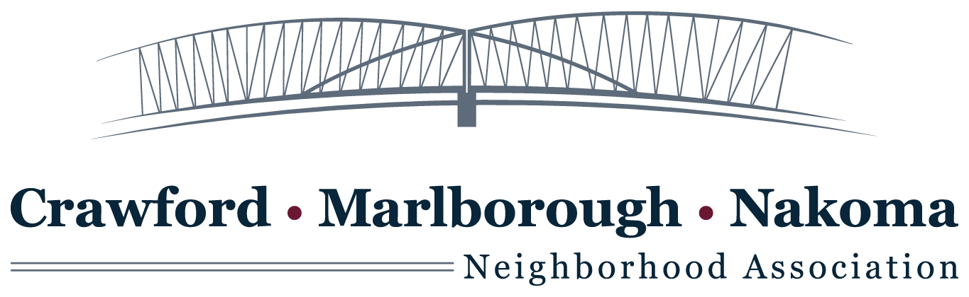

### Agenda - Board Meeting

**Monday, August 7, 2017**6:30 p.m. to 8:30 p.m.  
Sequoya Library  
4340 Tokay Blvd.

  1. Public Comment

  2. Approval of Minutes

3. Reports

a) President – Mary

b) Treasurer – Kim

c) Butterfly Garden Update

4. Unfinished Business

a) Annual Meeting Notification and Agenda

b) Draft of goals for CMNNA.org for 2018

c) Description of our Committees to encourage participation for 2018

d) Discuss ways to recruit Board members

e) Raising Funds for CMNNA.org by project or by general treasury

  5. New Business

a) Bylaws revisions for Annual Meeting

b) Setting dates for programs we are going to sponsor during 2018

City Forestry Department

Schools Forum

Good Neighbor Ideas and Forum

Building a relationship with The Friends of Lake Wingra

 (1)Mike Finnegan (2) Mary Odell (3) Kim Kindschi and Kevin Pomeroy (4) Ralph Stamler and Margie Zutter (5) Trish Iacarino and Barbara Granick (6) Sue Reget and Edward Lightbourn

At Large Carol Buelow

Residents/visitors: